Sprint 7 Report – Apr 23rd – 30rd

Bharathi Gadhiraju – Author

Stories Completed

* CSOFT-24 As a USER i want to enter building details SO THAT analysis can be completed
* CSOFT-54 As a CrowSoft engineer I WANT to deploy and test SELENIUM on our DEV server
* CSOFT-76 AS A CrowSoft engineer I WANT to create a test run to do a gradle build from github and push to Artifactory on the Build_Jenkins_Gold server SO THAT a pipeline can be started
* CSOFT-101 AS A team member I WANT to create a Disaster Recovery plan for the Project
* CSOFT-113 AS A team member I WANT to create a PowerPoint SO THAT we can present to the client
* CSOFT-115 As CrowSoft engineer I would like start setting up the pipeline on Jenkins so that automated builds will run
* CSOFT-116 As CrowSoft engineer I would like to set up an Ansible playbook to allow jenkins to connect to Dev server
* CSOFT-117 As a CrowSoft Engineer, I would like to secure our Staging Environment with SSL and Firewall, so that we secure our app and database
* CSOFT-118 AS A CrowSoft Engineer I WANT to install Build Scan on the Jenkins Gold server SO THAT the builds can be analysed
* CSOFT-119 AS A CrowSoft Engineer I WANT to start a test pipeline SO THAT I can get the Github, Gradle build and push to Artifactory to work in the pipeline
* CSOFT-120 As a CrowSoft Engineer, I would like to create a Production Server, so that we can host our web application
* CSOFT-121 AS A team member I WANT to create a Video overview SO THAT we can present to the client

# Stories In Progress

* CSOFT-14 As a customer, I would like to enter building header on an on-line system, so I add building features / details for a new building
* CSOFT-26 As a USER i want to the ability to upload files SO THAT the analysis can be assisted
* CSOFT-62 As CrowSoft Repository owner I would like to add webhook to github to allow Jenkins to trigger
* CSOFT-114 As a crowsoft team member I want to run sonar code analysis for MS build application

# Moving Forward

Four stories carried forward

# Burndown Chart

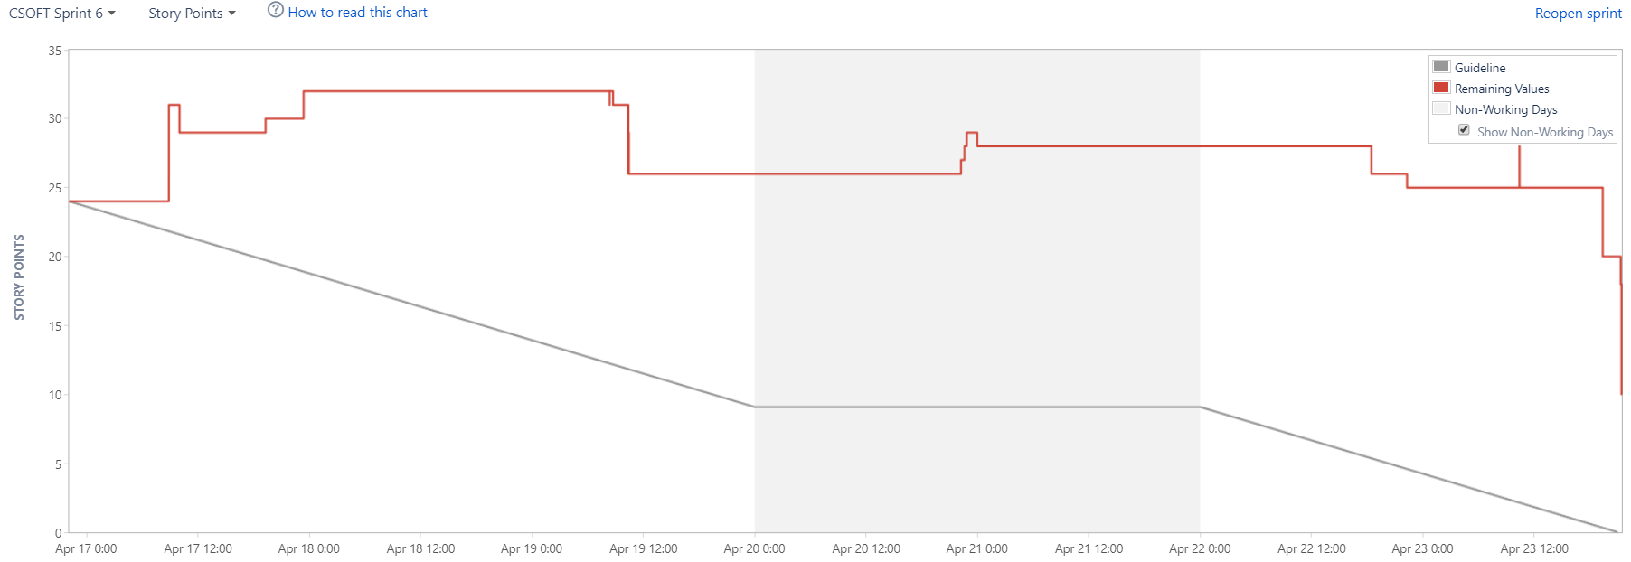

# Status Report

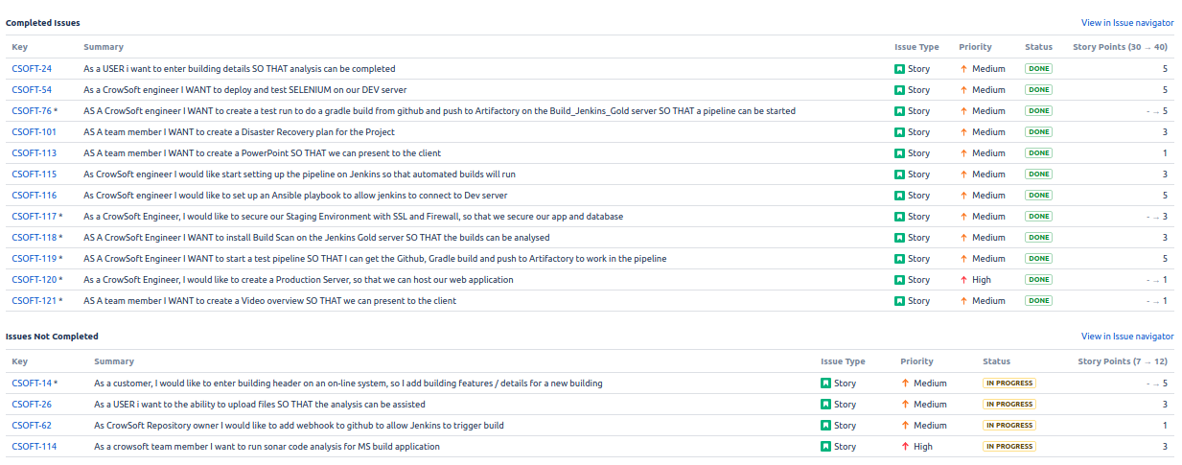

# Velocity Chart

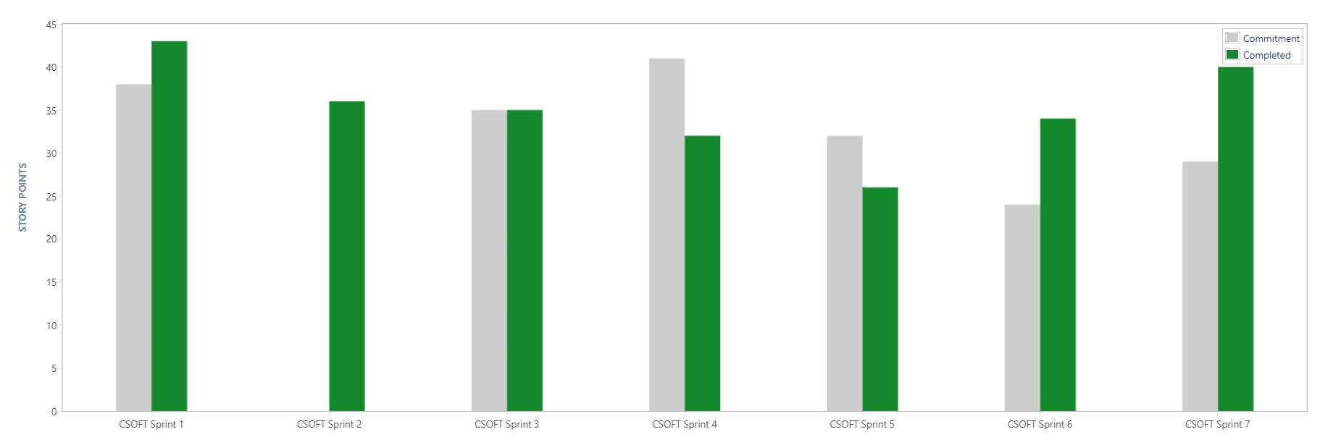

# Cumulative Flow Diagram



